Migrating from Power BI for Office 365 to Power BI Pro

**Summary:** We are making product and licensing updates to Power BI that will lead to limited support of the Power BI for Office 365 experiences by December 31, 2015, and deprecation of the Power BI for Office 365 experience by March 31, 2016. This document describes how to migrate from your existing Power BI for Office 365 experience to the new Power BI experience.

**Writer:** Adam Saxton

**Technical Reviewers:** Lorrissa Horton, Adam Wilson, Haydn Richardson, Maria Balsamo, Siva Harinath, Yaron Canari, Maggie Sparkman

**Published:** December 2015

**Applies to:** Power BI

Copyright

This document is provided “as-is”. Information and views expressed in this document, including URL and other Internet Web site references, may change without notice. You bear the risk of using it.

This document does not provide you with any legal rights to any intellectual property in any Microsoft product. You may copy and use this document for your internal, reference purposes.

© 2015 Microsoft. All rights reserved.

Table of contents

1 Introduction 3

1.1 Comparing the previous and new Power BI experiences 4

1.2 How to navigate between the two Power BI experiences 5

2 How to migrate BI content from a BI Site to Power BI 6

2.1 Move content from a BI Site to a group’s OneDrive for Business 6

2.2 Import Excel workbooks as datasets or as Excel Online workbooks 12

2.3 Set up data refresh 18

3 Administrator 18

3.1 Transition to the new experience 19

3.2 Licensing 19

# Introduction

We are making [product updates to Power BI](https://www.microsoft.com/en-us/powerBI/licensing.aspx) that will lead to limited support of existing Power BI for Office 365 experiences by December 31, 2015, and deprecation of the Power BI for Office 365 experience by March 31, 2016. If you’re a Power BI for Office 365 customer, don’t worry: You will still be able to use your existing Power BI for Office 365 licenses as Power BI Pro licenses for the new experience. After your Power BI for Office 365 licenses expire, and you need to use Pro features, you can add a new Power BI Pro subscription, or sign up for an individual Power BI Pro license.

The Power BI for Office 365 site will not be going away, but the level of support that will be provided will be limited to certain exception cases (e.g. security bugs). You should move to the new Power BI service prior to December 31, 2015 for continued production level support. If for some reason you are not able to move your business over, please let us know as soon as possible, so that we can aid in the migration over to the new service. You can send email to [sunsetPBIO365@microsoft.com](mailto:sunsetPBIO365@microsoft.com).

Learn more about [the new Power BI](https://powerbi.microsoft.com/).

## Comparing the previous and new Power BI experiences

This table compares key aspects of the two experiences.

|  |  |  |  |
| --- | --- | --- | --- |
|  | Previous experience | New experience | More info |
| Collaboration | Power BI team sites based on SharePoint Online | Group workspaces based on Office 365 unified groups | Groups |
| Manage permissions | Manage permissions to folders and workbooks in SharePoint Online | Manage group membership | Create a group |
| Quick access | Add favorite reports and featured Q&A questions | Pin visuals and Q&A answers to a dashboard | [Pin a tile to a dashboard](https://powerbi.microsoft.com/en-us/documentation/powerbi-service-pin-a-tile-to-a-dashboard-from-a-report/) |
| Edit Excel workbooks | Edit workbooks from the Power BI team site | Edit workbooks in Excel Online from Power BI, or in the Office 365 group | Whole Excel workbooks in Power BI |
| Natural Language Insight Discovery | Q&A | Q&A* | [Q&A in Power BI](https://powerbi.microsoft.com/en-us/documentation/powerbi-service-q-and-a/) |
| Scheduled Refresh | Via Data Management Gateway (DMG) | Via Personal Gateway | [Power BI Personal Gateway](https://powerbi.microsoft.com/en-us/documentation/powerbi-personal-gateway/) |
| Share Power Query queries in Excel | Access shared queries in the data catalog using the Power Query add-in for Excel | Access shared queries in the data catalog using the Power Query add-in for Excel | [Share queries in the Power BI Data Catalog](https://support.office.com/article/Share-queries-in-the-Power-BI-Data-Catalog-353B6B69-47F8-422E-BF7E-DB70BCA51EEA) |
| Mobile | View Excel worksheets and Power View sheets in the Windows app. This Windows app only works with previous-experience Power BI. | View Power BI dashboards and reports in apps for iOS (iPad and iPhone), Windows, and Android. These apps only work with new-experience Power BI. | [Power BI mobile apps](https://powerbi.microsoft.com/en-us/documentation/powerbi-power-bi-apps-for-mobile-devices/) |
| Personal Content | SharePoint Online based My Power BI | My Workspace for dashboards, reports and datasets | [Get started with Power BI](https://powerbi.microsoft.com/en-us/documentation/powerbi-service-get-started/) |
| Offer Types | Trial/Paid** | Free/Trial/Paid | Licensing |

*Q&A: Q&A modeling created in the previous service will continue to work in the new experience. The ability to model Q&A will be added to the new experience in the near future. More about [Q&A in the new Power BI experience](https://powerbi.microsoft.com/en-us/documentation/powerbi-service-q-and-a/).

**Note: All Power BI for Office 365 customers have access to the new experience automatically. Please see the Administrator Licensing section for more details.

## How to navigate between the two Power BI experiences

After you [sign up for the new Power BI experience](http://www.powerbi.com/), select the app launcher icon in the upper-left corner in Office 365 . Select the yellow Power BI icon in the app launcher menu (see below screenshot) to go to the new Power BI experience.

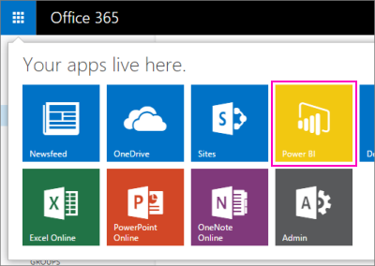

**Note**: If you still see the blue Power BI icon , then you don’t have a license for the new experience. [Sign up for the new Power BI](http://www.powerbi.com/).

You can also get to the new Power BI experience by browsing directly to <http://app.powerbi.com>.

To get to the Power BI for Office 365 experience, go to your SharePoint Online site > Site Contents > Power BI.

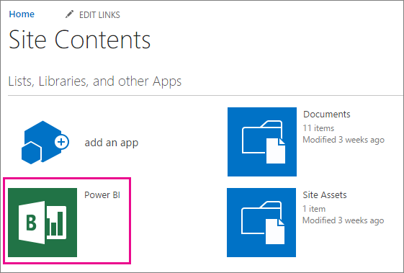

# How to migrate BI content from a BI Site to Power BI

In the previous experience, you had My Power BI for your own BI data, and your team collaborates in a BI Site. The following diagram illustrates the transition from the previous to the new experiences.

|  |  |  |  |
| --- | --- | --- | --- |
|  | **Previous experience – Power BI for Office 365** | **One-time migration performed by** | **New Power BI experience** |
|  |  |  |  |
| **Every user** has an individual BI workspace | **My Power BI**   * Favorite reports * Favorite questions * Favorite sites * Popular sites | **Every user** | **My Workspace**   * Dashboard with report tiles * Dashboard with Q&A tiles * My Workspace and Group Workspaces |
|  |  |  |  |
| **An organization** has several BI workspaces | **BI Site**   * Excel workbooks in doc library * Scheduled data refresh * Featured reports * Featured Q&A | **Site owner** | **Group Workspace**   * Excel workbooks on group’s OneDrive * Scheduled data refresh * Dashboard with report tiles * Dashboard with Q&A tiles |

Here are the steps for migrating from an existing Power BI Site to the new Power BI experience.

1. Move content from a BI site to a group’s OneDrive for Business site.
   * You may need to create a group first.
2. Choose whether to:

* Import Excel workbooks to use as datasets, or
* Connect to whole Excel workbooks and view them in Excel Online.

1. Set up data refresh.

## Move content from a BI Site to a group’s OneDrive for Business

OK, your team has a Power BI team site on SharePoint Online, and you're ready to migrate your content to the new Power BI.

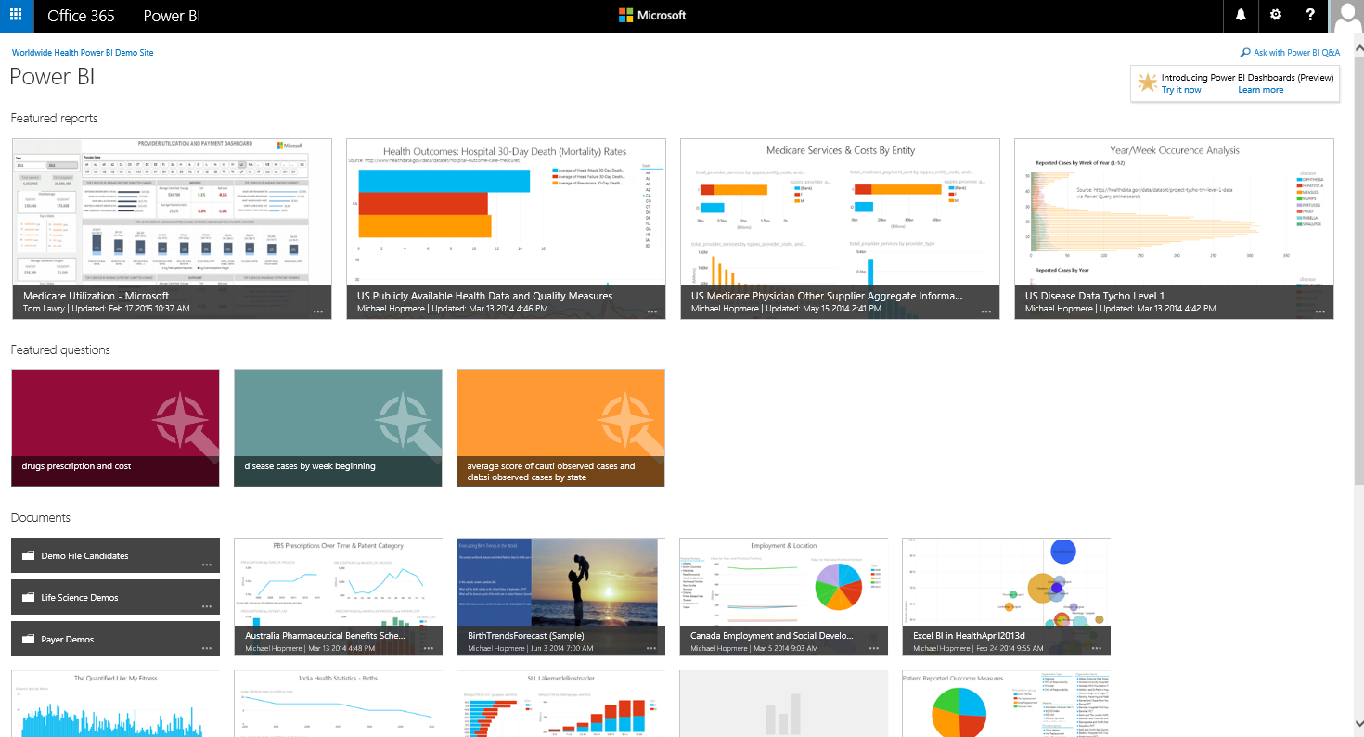

Before you can move your team’s workbooks to the new Power BI experience, you need an Office 365 unified group where you can store the workbooks. If you already have a group, skip to Move files from Power BI sites to local drive.

### Power BI groups

Power BI groups offer a powerful collaborative experience built on Office 365 groups. Read more about [groups in Office 365](https://support.office.com/Article/Find-help-about-Groups-in-Office-365-7a9b321f-b76a-4d53-b98b-a2b0b7946de1).

Groups in Power BI bring you and your colleagues together to collaborate, communicate, and connect with your data across Office 365. Create a group in either Power BI or Office 365. Then invite co-workers into this group to begin collaborating on your organization’s shared dashboards, reports, and datasets.

Collaboration doesn’t end with Power BI. It continues with other Office 365 group services like sharing files on OneDrive for Business, conversations in Exchange, calendar, tasks, and so on.

In Power BI, groups provide a work space where group members can collaborate on dashboards and reports. Read more about [groups in Power BI](https://powerbi.microsoft.com/en-us/documentation/powerbi-service-groups/).

### Create a group in Power BI

1. In Power BI, select the plus sign (+) next to **Group Workspaces**.

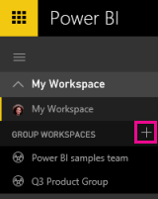

1. In the **Create a Group** pane on the right, fill in a group name. Power BI suggests a Group ID and lets you know if it's available. If it's not, select the pencil to the right of the Group ID box to modify it.

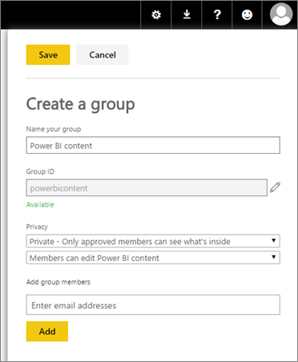

1. Select a privacy setting.

**Private**: Only group members can see the group’s contents.

**Public**: People in your organization can see the group’s contents even if they aren’t explicitly added as members of the group.

1. You can choose how members can work with the content. They can either be allowed to edit the content of the group, or view only.
2. Add members by typing in the **Add group member** box, or copying and pasting multiple email addresses from Outlook. Select **Add**.

**Note**: Currently you can't add team or security group aliases to groups.

1. Select **Save**.

Now you have a group where you can store files, and everyone in the group can work on them.

### Move files from an existing Power BI Site

The first step in moving files from an existing Power BI Site to a Power BI group is copying all the files. The easiest way to move all your group’s workbooks at once is to view your existing Power BI Site in File Explorer.

**Note:** Follow these steps if you want to move your Excel documents out of your SharePoint Online site and into OneDrive for Business. If you want to leave your Excel documents in your SharePoint Online site, skip this step and go to Import or connect to Excel workbooks.

1. Select the name of the site, in blue above the Power BI heading — in this case, Worldwide Health Power BI Demo Site.

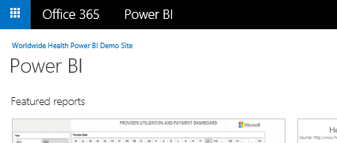

1. Select **Site Contents**.

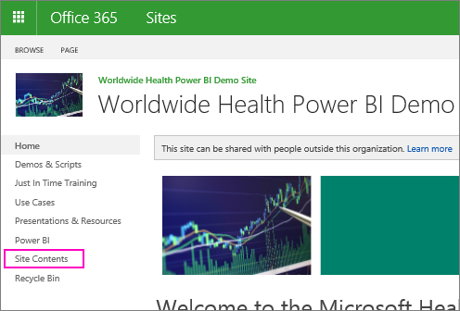

1. Select **Documents**.

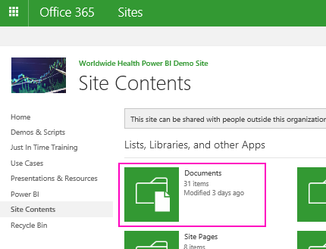

1. On the **Library** tab, select **Open with Explorer**.

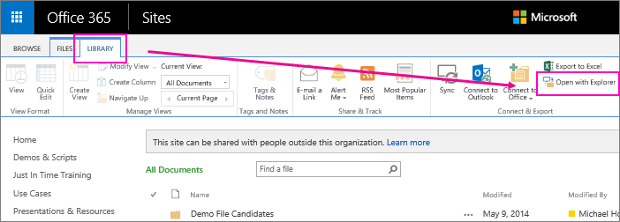

1. Select all, or press the Ctrl key and select just the workbooks you want to migrate.

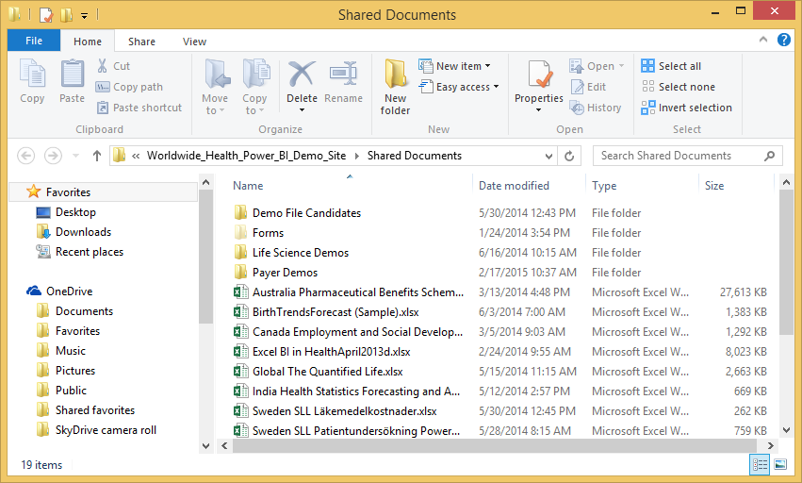

### Bulk upload to your group’s OneDrive for Business

1. In Power BI, switch to the group’s workspace, so the group name is in the top-left corner.

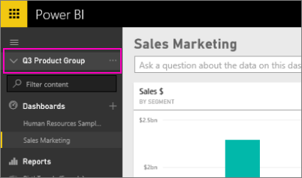

1. Select the ellipsis (…) next to the group name > **Files** to open the group’s OneDrive for Business on Office 365.  
   **Note:** If you don’t see **Files** listed, make sure you have a license assigned to you that includes OneDrive for Business.

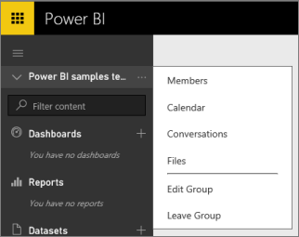

1. From here, you can bulk upload your files to your Office 365 group. Drag the selected files from the Explorer window to the area marked **Drag files here to upload**, and release them when you see **Drop here**.

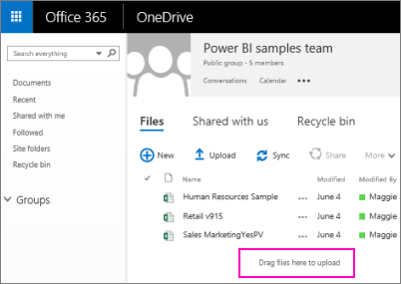

## Import or connect to Excel workbooks

Now that you’ve moved your workbooks over to your group’s OneDrive for Business, or you decided to leave your workbooks in SharePoint Online, you have a choice. You can:

* **Import the Excel workbook** as a dataset, and use the data to build reports and dashboards you can view in a web browser and on mobile devices. Or:
* **Connect to Excel workbooks in Excel Online** and display your Excel workbooks in Power BI exactly as they appear in Excel Online and in the previous Power BI experience.

**Note**: Use this method to view large workbooks in Excel Online. Read more about [Excel workbook size](https://support.office.com/en-us/article/Reduce-the-size-of-an-Excel-report-on-a-Power-BI-for-Office-365-site-c1a9215c-1c10-4de4-9b7a-50ea6782f8de).

### Import the Excel workbook as a dataset into your group’s workspace

1. Switch to your group’s workspace. 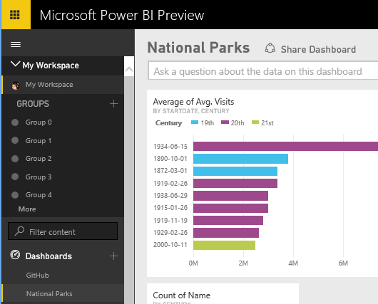
2. Select **Get Data** at the bottom of the left navigation pane.

 https://powerbi.uservoice.com/assets/82642324/PBI_GetData.png

1. Under **Files,** select **Get**.

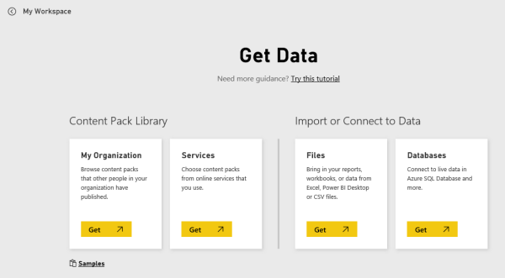

1. Select the OneDrive for Business for your group name, if you moved the workbooks over to a group OneDrive. Or, if you left your workbooks on SharePoint Online, select **SharePoint – Team Sites**.  
     
   **Note:** If your files are on your root SharePoint Online team site, you can connect those files to Power BI through **Get Data > Files > SharePoint - Team Sites**. You will soon be able to supply a URL to any SharePoint Online site, and connect to your files.

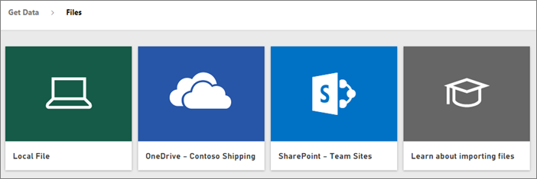

1. Select the file you want and select **Connect**.

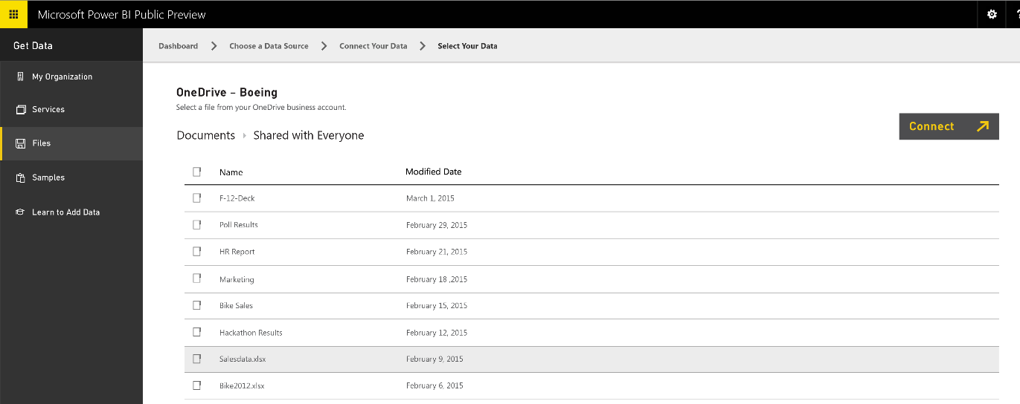

1. Under **Import Excel data into Power BI**, select **Import.** Power BI creates a dataset based on the data model in the workbook.

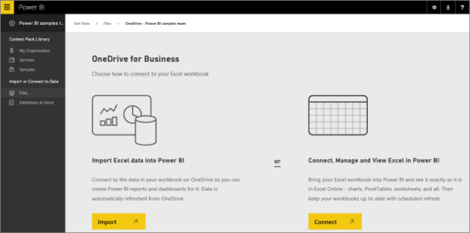

The dataset appears in the left navigation pane under **Datasets**, with a yellow asterisk to show it’s new.

Now that you’ve imported the data as a dataset, you can [create team dashboards](https://powerbi.microsoft.com/en-us/documentation/powerbi-service-create-a-dashboard/) for an at-a-glance view of your insights and reports, or [create organizational content packs](https://powerbi.microsoft.com/en-us/documentation/powerbi-service-organizational-content-packs-introduction/) for your group or your company.

### Connect to, manage, and view intact Excel workbooks in Power BI

You can display Excel workbooks in Power BI exactly as they appear in Excel Online.

**Note**: Use this method to view large workbooks in Excel Online.

1. Switch to your group’s workspace.



1. Select **Get Data** at the bottom of the left navigation pane.

 https://powerbi.uservoice.com/assets/82642324/PBI_GetData.png

1. Under **Files,** select **Get**.



1. Select the OneDrive for Business for your group name, if you moved the workbooks over to a group OneDrive. Or, if you left your workbooks on SharePoint Online, select **SharePoint – Team Sites**.

**Note:** If your files are on your root SharePoint Online team site, you can connect those files to Power BI through **Get Data > Files > SharePoint - Team Sites**. You will soon be able to supply a URL to any SharePoint Online site, and connect to your files.



1. Select the file you want and select **Connect**.



1. Under **Connect, Manage, and View Excel in Power BI**, select **Connect**.



Power BI creates a connection to the Excel workbook.

The workbook appears in the left navigation pane under **Reports**, with an Excel icon next to it.   
  
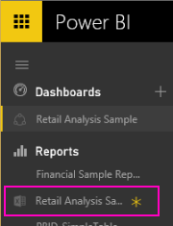

## Set up data refresh

For the workbooks that you have selected to view as Excel workbooks, set up data refresh yourself using your Personal Gateway.

### Schedule data refresh via Personal Gateway

1. Select the ellipsis (…) next to a report > **Schedule Refresh**.
2. Follow the steps in [Power BI Personal Gateway](https://powerbi.microsoft.com/en-us/documentation/powerbi-personal-gateway/).

# Administrator

The previous Power BI experience offers the following administrative capabilities for managing data refresh and roles, including Power BI Admin and Data Steward roles.

* **Power BI Admin Role and Group Management:** Add users to or remove users from the Power BI admin role. Create and manage groups of people who can manage data sources.
* **System Health Monitoring:** Monitor data refresh related issues through log monitoring.
* **Settings:** Apply security settings, and notification preferences.
* **Data Source Management:** Add on-premises and cloud data sources to be used with a Data Management Gateway. Provide Access Control Lists (ACLs) for users who can access these data sources.
* **Data Management Gateway:** Manage on-premises Data Management gateway instances.
* **Data Steward Management:** Add or remove users who can certify shared queries in the data catalog.

## Administrator transition to the new experience

The Power BI Admin Center will be in limited support by December 31, 2015, and deprecation by March 31, 2016. The Power BI Admin Center does not work with the new experience.

## Licensing

The Power BI experience is available through a number of paid and trial offers.

### Existing paid or trial users

If your users have Power BI for Office 365 licenses as part of any offer, they will have access to both the previous experience and the Power BI Pro version of the new experience until the Power BI for Office 365 License expires. After the license expires, they can sign up to get the free, trial, or paid versions of the new experience individually at [www.powerbi.com](http://www.powerbi.com). You can also enroll users in free or paid versions of the new experience through the Office 365 Admin portal.

**Note**: The tenant admin can prevent existing users from starting to use Power BI. Read about [disabling automatic license distribution](https://support.office.com/article/Power-BI-in-your-organization-d7941332-8aec-4e5e-87e8-92073ce73dc5#BKMK_PreventExistingUsersStarting).

### Trial users

When the trial expires, your users will no longer have access to any Power BI experience. They can sign up to get the free, trial, or paid versions of the new experience individually at [www.powerbi.com](http://www.powerbi.com). You can also enroll users in free or paid versions of the new experience through the Office 365 Admin portal.

**Note**: The tenant admin can prevent existing users from starting to use Power BI. Read about [disabling automatic license distribution](https://support.office.com/article/Power-BI-in-your-organization-d7941332-8aec-4e5e-87e8-92073ce73dc5#BKMK_PreventExistingUsersStarting).

### Adding more users

You can no longer purchase new Power BI for Office 365 licenses, now that the new experience is generally available (GA).

### New tenants

You can’t purchase Power BI for Office 365 licenses, now that the new experience is generally available (GA).

# Frequently Asked Questions

For a list of frequently asked questions (FAQ), please refer to the Power BI documentation. [Learn more](http://go.microsoft.com/fwlink/?LinkID=718045)